|  |  |  |
| --- | --- | --- |
| Project Settings: <https://drive.google.com/open?id=1bIWSzxDlhNRyUOUX_9wq728ZlzKtD0T2mv1hEl6MYnA>  Please view project settings before start | | |
| Project Check Sheet: none  Please use check sheet after completing this task | | |

1. **Task Requirement / Description**
2. **UI Flow**
3. **Programming Logic**
4. **Database**

**1. Task Requirement / Description**

Please add a link to dynamically create a pdf for download to the download catalog page. The catalog will generate a pdf book with:

1. Front page - Merriman Logo
2. Contents page - show a list of category in an ordered list ( like html <ol> )
3. Product page - show Category in heading and page contents is same like website product page

Add a small merriman logo on each page at top of each page

If possible please add a “please wait” message for the user while pdf is generated. Once pdf is generated then direct browser to download.

Merriman paper catalog for example:

<see next page>

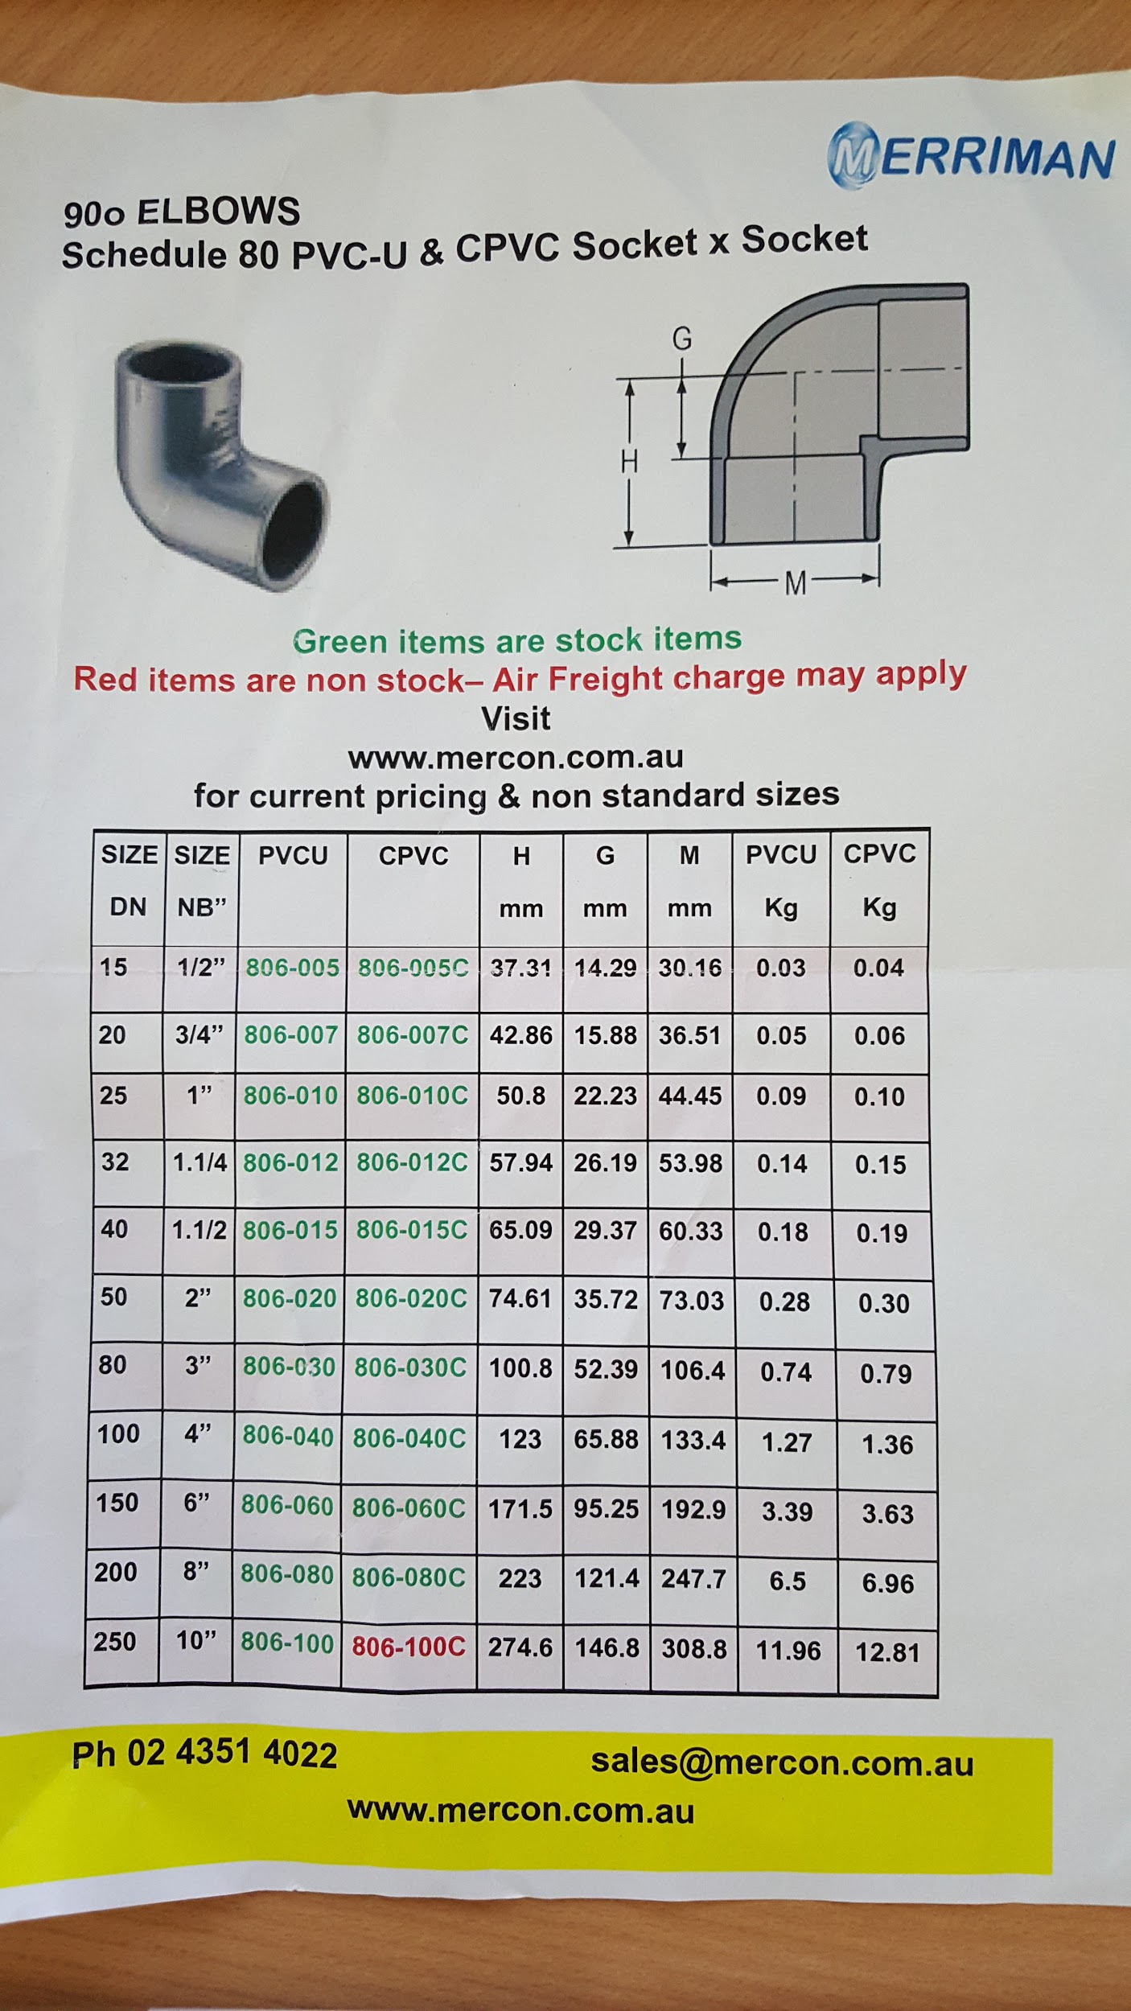

**2. UI Flow**

<See next page>



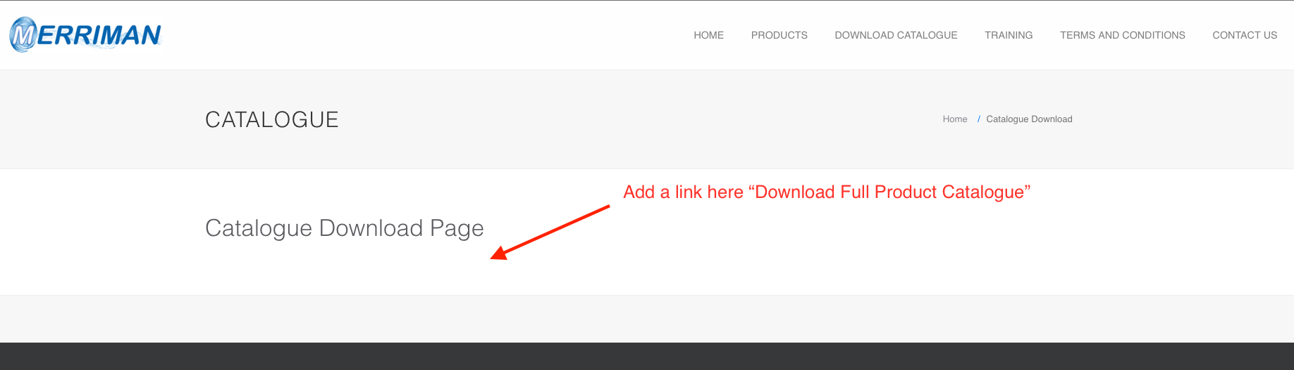

**3. Programming Logic**

1. User clicks link “Download Full Catalogue”
   1. Get all categories in order of category.sequence
   2. Loop over categories in contents page and show <ol> list of category names
   3. Get all products group by category and order by sequence
   4. Loop over all products
      1. If category name change do a page break and show category name in bold
         1. Show products in category
            1. Show details for product including image ( same like website )
   5. Direct browser to download generated pdf

**4. Database**

No change

END

1. Install Instruction
2. Update from svn

* Url to generate pdf file

Base_url/generate_catalogue